Sunday Monday Tuesday Wednesday Thursday Friday Saturday  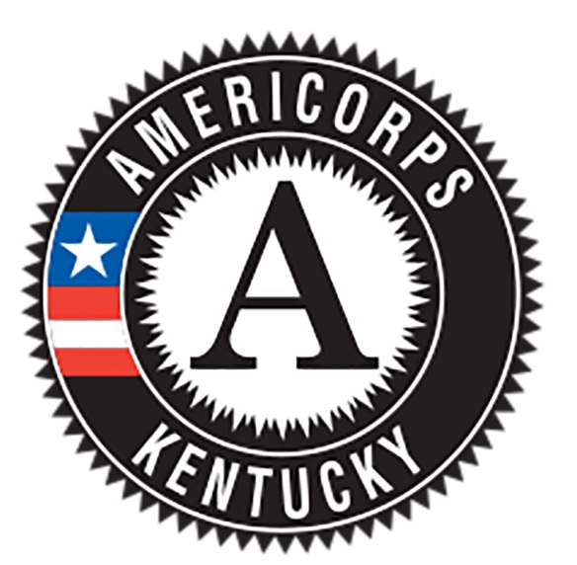  AUGUST 2020 |  |  |  |  |  |  | NOTES  KCC Kick-Off Training- August 3rd-31st, This year’s Kick-Off training will consist of multiple Zoom sessions throughout August. See training agenda on KCC Shared Drive for more details.  ACT—actstudent.org  College Access Resources- kheaa.com  KHEAA Initiatives- kygoestocollege.com
 |  |  |  |  |  | 1
2 | 3 Kick-Off Training/Orientation Begins | 4 | 5 | 6 | 7 | 8
9 | 10 | 11 | 12 AmeriCorps PD Webinar | 13 | 14 Registration Deadline for September ACT Dates | 15
16 | 17 | 18 | 19 | 20 | 21 Timesheet | 22
23 | 24 | 25 | 26 | 27 | 28 | 29
30 | 31

Sunday Monday Tuesday Wednesday Thursday Friday Saturday  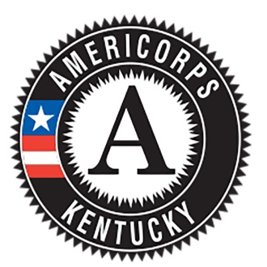  SEPTEMBER 2020 |  |  |  |  |  |  | NOTES  Webinar- 10am Eastern Time (9am Central Time)  Career Interest Interviews- Consider using the following resources to discuss career options with core students:  - Exploring Careers section on kheaa.com  - CareerOneStop Videos  - Occupational Outlook Handbook  GSP- Governor’s Scholars Program registration will be open this month  KHEAA Initiatives- kygoestocollege.com
 |  | 1 | 2 | 3 | 4 Timesheet  Monthly Report | 5
6 | 7 | 8 | 9 AmeriCorps PD Webinar | 10 | 11 National Day of Service | 12 ACT
13 ACT | 14 | 15 Deadline for Career Interest Interviews | 16 | 17 Registration Deadline for October ACT Dates | 18 Timesheet | 19 ACT
20 | 21 | 22 | 23 | 24 | 25 | 26
27 | 28 | 29 | 30

Sunday Monday Tuesday Wednesday Thursday Friday Saturday  OCTOBER 2020 |  |  |  |  |  |  | NOTES  Free Application For Federal Student Aid (FAFSA)—fafsa.gov  Getting the Facts (GTF)—an online college cost comparison tool available at kheaa.com  Make a Difference Day is the largest national day of community service. On the fourth Saturday of October, millions of volunteers around the world unite in a common mission to improve the lives of others. Make A Difference Day is a day to celebrate the power of people to make a difference.  ACT—actstudent.org  Webinar—10am EST  KHEAA Initiatives- kygoestocollege.com
 |  |  |  | 1 2021-22 FAFSA Opens!!!  Deadline for core student entry into OnCorps | 2 Timesheet  Monthly Report | 3
4 | 5 | 6 | 7 | 8 | 9 | 10 ACT
11 | 12 | 13 | 14 AmeriCorps PD Webinar | 15 | 16 Timesheet | 17 ACT
18 | 19 | 20 | 21 | 22 | 23 | 24 Make a Difference Day  ACT
25 ACT | 26 | 27 | 28 | 29 | 30 Deadline for core senior FASFSA completion/GTF | 31

Sunday Monday Tuesday Wednesday Thursday Friday Saturday  NOVEMBER 2020 |  |  |  |  |  |  | NOTES  KHEAA Initiatives- kygoestocollege.com  Webinar—10:00 am ET  National First Generation College Student Day- November 8th, national campaign to celebrate the success of first-generation college students. For more info: https://firstgen.naspa.org/engagement/first-generation-college-celebration
1 | 2 | 3 | 4 | 5 | 6 Timesheet  Monthly Report  ACT Reg. Deadline | 7
8 National First Generation College Student Day | 9 | 10 | 11 AmeriCorps PD Webinar | 12 | 13 | 14
15 | 16 | 17 | 18 | 19 | 20 Timesheet | 21
22 | 23 | 24 Deadline for core senior college admission app completion | 25 | 26 | 27 | 28
29 | 30

Sunday Monday Tuesday Wednesday Thursday Friday Saturday  DECEMBER 2020 |  |  |  |  |  |  | NOTES  Your core 10th grade students should create a MyKHEAA account through kheaa.com and check their KEES award!  Your mid-year performance evaluations should be completed and discussed by your site supervisor and PA this month.  Webinar—10am ET
 |  | 1 | 2 | 3 | 4 Timesheet  Monthly Report | 5
6 | 7 | 8 | 9 AmeriCorps PD Webinar | 10 | 11 Deadline for core 10th graders to register for MyKHEAA account | 12 ACT
13 | 14 | 15 | 16 | 17 | 18 Timesheet | 19
20 | 21 | 22 | 23 | 24 | 25 | 26
27 | 28 | 29 | 30 | 31

Sunday Monday Tuesday Wednesday Thursday Friday Saturday  JANUARY 2021 |  |  |  |  |  |  | NOTES  Mentoring Month—National Mentoring Month is an annual, high-profile campaign to draw attention to the need for more volunteer mentors to help America’s young people achieve their full potential.  MLK Day—The Martin Luther King Jr. Day of Service is a way to transform Dr. King’s life and teachings into community service that helps empower and strengthen local communities.  KCC Mid-Year Training- January 18th-20th, location tbd
 |  |  |  |  | 1 Timesheet  Monthly Report | 2
3 | 4 | 5 | 6 | 7 | 8 Registration Deadline for ACT in Feb | 9
10 | 11 | 12 | 13 AmeriCorps PD Webinar | 14 | 15 Timesheet | 16
17 | 18 MLK Day  National Day of Service | 19 KCC Mid-Year Training | 20 KCC Mid-Year Training | 21 | 22 | 23
24 | 25 | 26 | 27 | 28 | 29 | 30
31

Sunday Monday Tuesday Wednesday Thursday Friday Saturday  FEBRUARY 2021 |  |  |  |  |  |  | NOTES  ACT- actstudent.org  march2success.com  Webinar—10am ET  Getting the Facts (GTF)—an online college cost comparison tool available at kheaa.com  Mastery Prep- Practice ACT kit that helps core sophomores improve testing skills. By February 14th, plans should be made for utilizing your test kits with all core sophomores. Many coaches will offer the practice test to core sophomores while juniors take the state ACT in March. Be sure to discuss all plans with school administration!
 | 1 | 2 | 3 | 4 | 5 Timesheet Monthly Report | 6 ACT
7 | 8 | 9 | 10 AmeriCorps PD Webinar | 11 | 12 Deadline for planning spring ACT Prep Workshops | 13
14 | 15 | 16 | 17 | 18 | 19 Timesheet | 20
21 | 22 | 23 | 24 | 25 | 26 Deadline for core juniors to complete GTF report | 27
28

Sunday Monday Tuesday Wednesday Thursday Friday Saturday  MARCH 2021 |  |  |  |  |  |  | NOTES  ACT—actstudent.org  march2success.com  Getting the Facts (GTF)—an online college cost comparison tool available at kheaa.com  AmeriCorps Week, March 8th-12th —each year during AmeriCorps Week, we recognize the commitment of AmeriCorps members and alums by highlighting the extraordinary impact AmeriCorps makes across our nation every day.  KCC Webinar—10am ET  State ACT for 11th grade- All high school juniors in Kentucky take the ACT for free during the normal school day on March 9th.
 | 1 | 2 | 3 | 4 | 5 Timesheet Monthly Report | 6
7 | 8 AmeriCorps Week! | 9 AmeriCorps Week!  State ACT for juniors | 10 AmeriCorps Week!  AmeriCorps PD Webinar | 11 AmeriCorps Week! | 12 AmeriCorps Week!  Reg. Deadline for April ACT | 13
14 | 15 | 16 | 17 | 18 | 19 Timesheet | 20
21 | 22 | 23 | 24 | 25 | 26 | 27
28 | 29 | 30 | 31 Deadline for ALL juniors to complete GTF reports
Sunday Monday Tuesday Wednesday Thursday Friday Saturday  APRIL 2021 |  |  |  |  |  |  | NOTES  ACT—actstudent.org  National Service Recognition Day- Every day, in counties and cities across America, national service is tackling tough problems and strengthening communities. On April 6th, 2020, county officials and mayors across the country will thank those who serve and recognize their impact on the National Service Recognition Day.  KCC Webinar—10am ET  KCC End of Year Training- April 27th, 28th, and 29th. Location TBD
 |  |  |  | 1 | 2 Timesheet  Monthly Report | 3
4 | 5 | 6 National Service Recognition Day | 7 | 8 | 9 | 10
11 | 12 | 13 | 14 AmeriCorps PD Webinar | 15 | 16 Timesheet | 17 ACT
18 | 19 | 20 | 21 | 22 | 23 | 24
25 | 26 | 27 | 28 | 29 | 30 Timesheet

Sunday Monday Tuesday Wednesday Thursday Friday Saturday  MAY 2021 |  |  |  |  |  |  | NOTES  National College Decision Day—student should notify the college they plan to attend by this day!  Verification—some of your students will be asked to verify information on their FAFSA. Financial aid cannot be disbursed until this process is complete!
 |  |  |  |  |  | 1 National College Decision Day
2 | 3 | 4 | 5 | 6 | 7 Monthly Report  Reg. Deadline for June ACT | 8
9 | 10 | 11 | 12 AmeriCorps PD Webinar | 13 | 14 Core Senior Scholarship Reporting Deadline | 15
16 | 17 | 18 Core senior verification completion deadline | 19 | 20 | 21 Timesheet | 22
23 | 24 | 25 | 26 | 27 | 28 | 29
30 | 31 Final Timesheet/Monthly Report

